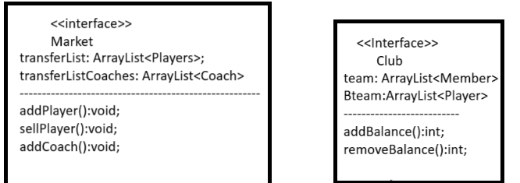

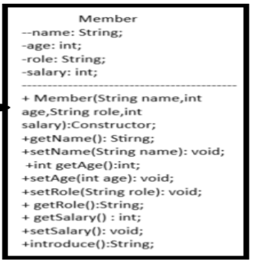

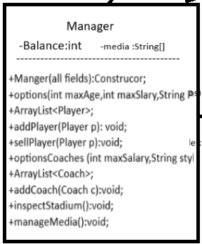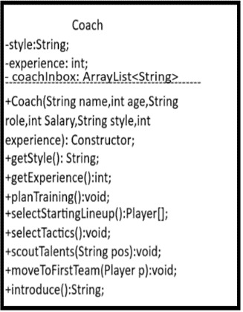

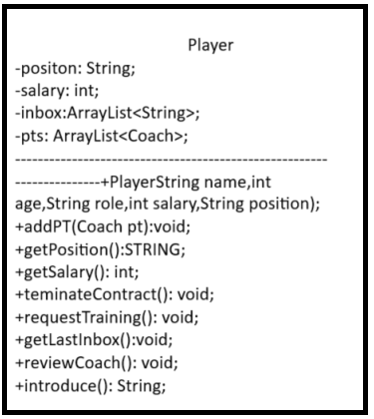

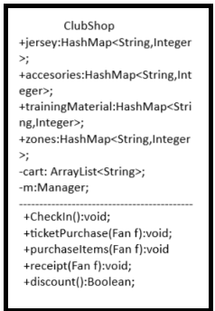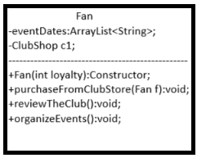

Interface Club:
Team: filed that represents the teams roster;
Bteam : represents the second team which has talents and youngsters;
addBalnce(): add the balance of the club;
removeBalance(): remove form the club balance;
-------------------------------------------------------------------------------------------------------------------------------------------------------
Interface Market:
transferList: List that contains all players that are available for sale;
tarferListCoaches: List that contains all coaches that are available for sale;
-------------------------------------------------------------------------------------------------------------------------------------------------------
Manager Class:
It is ingerited by upcomimg classes;
Member(all fields): constructor for the class member;
getName(): get the name of the member;
setName(): set name of the member;
getAge()://;
setAge()://;
getRole()://;
setRole()://;
getSalary()://;
setSalary()//;
aintroduce: returns a string that represents the member;
-------------------------------------------------------------------------------------------------------------------------------------------------------
Manger class extends Manager class and implements Club and Market:
Balance: a private field to keep track of the balance of the club which is the manager responsibility;
Media: an array containing string representations of the dates on which the manager has press conferences;
Manager(all fields): Constructor for Manager class;
Options(int maxAge,int maxSalary, String position): returns all available options of player available in the transfer market based on the manager preferences;
addPlayer(Player p): the manager selects a player from the transfer list and adds it to team, It also removes the salary of the new player form the teams balance;
sellPlayer(Player p): sells player and adds hi salary to the balance;
optionsCoaches(): same as options mentioned previously but for coaches;
addCoach(): removes old coach and add the new one + edits balance;
inpsectStadium(): asks the manager to improve stadium’s condition by spending money form clubs balance;
manageMedia(): Display the upcoming press conferences for the manager and asks the manager if he wants to remove any press conference;
------------------------------------------------------------------------------------------------------------------------------------------------------
Coach class extends member:
style: represents coach’s style;
Experience: represents the number of years the coach has been working;
Coach(all fields):Constructor for Coach class;
getStyle(): get style of coach;
getExperience(): get experience years;
planTraining(): asks the coach to enter the date for his next training session and adds the date to playes inbox;
selectStartingLineup(): iterates through payers in the team and asks the coach to select three of the players as the starting lineup then displays the final starting team;
selectTactics(): asks the coach to enter his attacking + defending tactics and formation then displays the tactics for the upcoming match;

scoutTalents(String pos): based on the entered position talents from the B team are displayed to coach;
moveToFisrtTeam(Player p): moves the player p to first tea from B team;
introduce(): overrides to display coach details
Coach Player extends Member:
Position: represents player position in field;
Salary: represents player salary;
Inbox: list of player inbox;
Pts: list of all personal trainer the player has;
Player(all fields): Constructor;
addPT: adds a personal trainer to the list;
getPositon():returns position;
terminateContract():terminates player contract and removes from team;
requestTraining(): the player requests a training session from his pt and the pt is messaged;
getLastInbox(): prints last inbox the player has;
reviewCoach():where the player can mail the coach about any concerns;
introduce() :overrides to introduce the player;
-------------------------------------------------------------------------------------------------------------------------------------------------------ClubShop:
checkIn(): method to introduce shop users and check their presence;
purchaseItems(): the user chooses if he wants jerseys, accessories, or training materials, then is shown the map of items and his prices, then what he chooses is added to the cart;
ticketPurchase():the user can purchase ticket for different zones and prices, also added to cart;
receipt():shows the user his receipt of all items and their prices + the total sum;
discount(): Boolean method that check if the loyalty field for a fan exceeds or is equal to 10, if so it gives a discount of 20% on all the purchases;
Fan:
purchaseFromClubShop(): executes all methods found in ClubShop class(the user has a shopping experience);
reviewClub(): the fan can send feedback to club members;
organizeEvents(): the fans can set event dates which are added to the eventDates list;

